Week 7 (March 30 – April 03)
TEACHER’S COPY
READING CAFÉ 4
On the menu this week is:
PART I
VOCABULARY REVISION
- Complete the text with the words given in the box.
pure | dimensions | symbol | nearby
reunified | reserved | restricted | illustrates

Hawaii
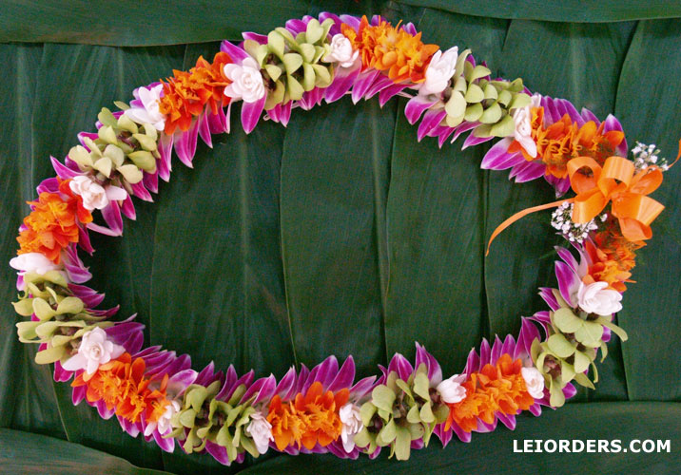In present- day Hawaii, there are at least twelve different ethnic groups. The largest groups are the Japanese, the Europeans, the Chinese, the Filipinos, the part-Hawaiians and the people from mixed families. Everyone has more opportunities to meet people of other ethnic groups and to learn about their culture. With this experience, people can learn to respect each other’s ideas and ways of life. This illustrates that children grow up to be more tolerant as adults, more willing to accept differences. In the long run, it can mean less social tension, and probably less poverty and violence.

One way to measure the level of tolerance in Hawaii is by the percentage of mixed marriages. Marriages between people from different ethnic groups aren’t restricted. Children from mixed marriages are called ‘hapas’. If their parents are separated, they can meet again after a while and can be reunited. Usually they do not need to make a big ceremony again and they choose to go to a nearby church to marry. Also, it will be getting hard to see pure Hawaiian as most people are mixed with other cultures.

One of the most important traditions is very much alive today - wearing “lei” ( a necklace made of flowers). Leis are created from the many kinds of fresh flowers found on the island. The flowers are sewn together to form a large circle. The dimensions of leis differ from one meter to two meters. They are still symbol of peace and friendship. A colourful, long lei is prepared and reserved for a non-Hawaiian visitor by a host family. When the guest arrives, the lei is placed his or her neck, with the traditional greeting, “Aloha”.

- Complete the sentences below using the correct form of the words in the box.
impact x 2 | wrap | demonstrate | grip

- Dressing well for a job interview and showing up on time is considered a demonstration of your seriousness about the job.
- In traditional Kırkpınar wrestling competitions, each wrestler impacts his rival with great force and try to knock them down.
- You can keep your roommate from trying to change the channel by gripping the TV remote controller or hiding it.
- She wrapped her old set of porcelain cups in a cloth, put them in plastic bags and then packed them inside boxes in the garage.
- A new manager has come into our department and he quickly wants to make an impact, so he is trying to offer creative ideas for the new project.

PART II
STRATEGY PRACTICE MAKES PERFECT
DISTINGUISHING FACTS FROM OPINIONS

The information in a text consists of facts and opinions. Distinguishing between the two different types of statements is a critical reading skill which helps comprehension.
- Facts are statements that you can prove. In other words, they are general truths and are agreed to be true by everyone. Examples of this kind of information are statistics, proper names, dates, true stories, experiment or survey results.

- Opinions are the writer’s personal ideas. You cannot prove opinions because they show beliefs, conclusions or judgements, which can change from person to person.

The following sentences are examples of facts:
All living things need water to exist.
Air pollution causes acid rain.
Light, like heat, is a form of energy.
A can is a metal container.

The following sentences are examples of opinions:
It is believed that computers are good for children’s coordination.
We will probably have enough coal for another 400 year.
Electric cars may replace today’s cars in the near future.
I don’t think people can learn Japanese from CD.
Keeping Fact and Opinion Apart
- Look for words that interpret.
Read the following sentences.
- The man leaning against the fence had brown eyes and black hair touching his shoulders.
- A handsome man leaned against the fence.

In the first sentence we have details that describe facts without any evaluation. In the second sentence, its writer’s opinion that such a man is handsome and the writer interprets the details for us. Words that interpret are countless such as pretty, ugly, dangerous, evil, attractive, well-dressed, good-looking and so on.

- Look for words that serve as clues that serve as statements of opinion. Some words like probably, perhaps, maybe, usually, often, sometimes, on occasion are used to limit a statement of fact and to indicate the possibility of other opinions.
Other words say clearly that an opinion will follow; these are words like I believe, I think, I suppose, I feel…
- Test the writer’s opinion by asking whether a different opinion is possible. You do not have to agree with the different opinion (or with the author’s, for that matter). You just have to be able to see if there is another point of view.

- Read the following sentences. Write O (opinion) or F (fact) near the sentences and explain Why?

_O__ 1. “Death on the Nile” was the most exciting movie of one of Agatha Christie’s stories.

_F__ 2. The astronomical evidence proves that the Universe was created 20 billion years ago in big explosion.

_O__ 3. There is a kind of religion in science; it’s the religion of a person who believes there is order and
harmony in the Universe and every event can be explained in a rational way.

_F__ 4. The Pacific Ocean is three times bigger than Asia, the biggest continent on Earth.

_O__ 5. In six years’ time, you may be able to cruise the sky in luxury planes. The planes will probably
have everything a person could want while travelling long distances.

_F__ 6. Iceland has 200 volcanoes and Indonesia has more than 600.

_F__ 7. According to statistics, almost a million earthquakes occur every year.

_O__ 8. Children who sit around a table in a group learn more easily and better than ones sitting in rows.

_O__ 9. It may be possible to breed cows weighing 5 tons, about the size of an elephant, in the near future.

_F__ 10. Out of all the fish caught in the world, about three quarters are eaten as food. The other quarter
is used to make such things as glue, soap, margarine, pet food.

_O__ 11. There seems to be too much standardized testing in public schools.

_O__ 12. People should not be allowed to talk on cell phones in a movie theatre.

_O__ 13. The television show The Simpsons is just not as funny as it used to be.

_O__ 14. There is widespread concern about the possible negative effects on behaviour of listening to
certain types of music, particularly in adolescents.

_O__ 15. It was at first thought that perhaps music was the cause of teenagers’ behavioural problems to
some extent.
PART III
READING
- Answer the questions below.

- Are your parents happily married?
- How did they meet? Had they loved each other first or did they have an arranged marriage?
- Which one is better: love marriage or arranged marriage?
- Would you like to have an arranged marriage? Why/why not?
- In what cultures, is arranged marriage practiced?

- Look at the pictures and discuss them.
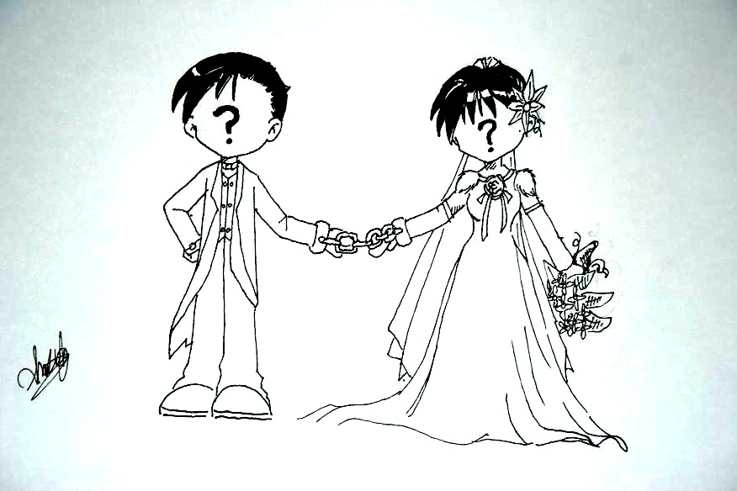
A
B

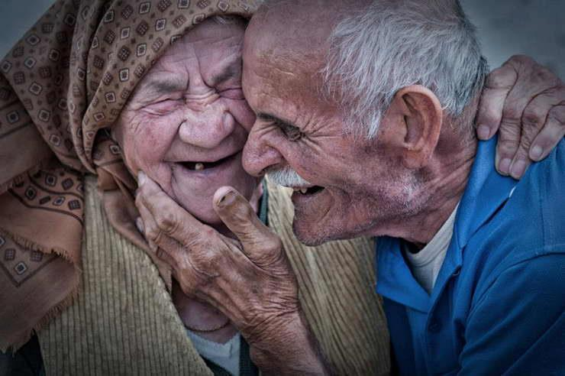
C
D
D

- Read the text and answer the questions.

ROMANCE IN JAPAN

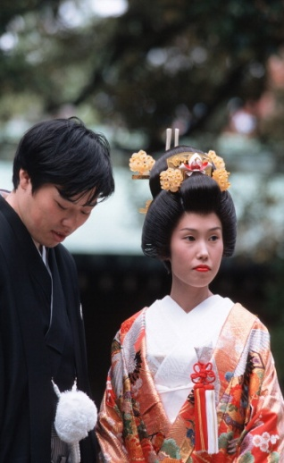[The Japanese concept of love is a little different from the Western concept of love. A young Japanese couple talks about love from their personal experience in this article.]

[1] When Mr. Yoji Morita married Miss Tamiko Minemura last year, his father compared the couple’s new life together to a train ride on a long unknown track. “There may be curves and dark tunnels ahead,” he told them, “but we wish you a safe journey.”

[2] The first year of that journey together has provided a variety of personal discoveries about everything from dirty laundry to family finances for the new couple. However, overall, the young couple thought that their arranged marriage was going well, and they felt a certain closeness slowly developing between them. They call it ‘love’.

[3] “I feel so relaxed when I get home with him,” says Tamiko while Yoji says: “She does such nice things”, and he adds: “The other day when I was sick in bed, she gave up a visit to her parents’ house and stayed home and took care of me.”

[4] During each of their five work days a week, they talk by phone and almost always meet each evening to make the one-hour train ride home together. In the streets, they hold hands. In restaurants, they sometimes playfully touch each other. These are subtle but significant changes in the growth of a Japanese marriage relationship, where open signs of affection are not common. It is quite different from the day when they met at an arranged tea after their fathers who were old friends from work, exchanged photographs and suggested the possibility of a marriage between their two children. The two young people, who could have said no to the idea, did not even get to speak at first.

[5] Ten days after this meeting, Yoji proposed Tamiko to marry. “I will make you happy,” Yoji promised. Although Tamiko decided almost immediately, she just smiled at him and waited three days to answer.

[6] Then, in October, Japan’s most popular marriage month, the two families came together in a wedding and reception that cost about $13,600. It was planned to be the most important day in their lives. The two newlyweds, who had never kissed each other until that day, spent their wedding night on the 19th floor of a nearby hotel. Then, they left for a quiet southern holiday resort on a three-day honeymoon.

[7] They started to dwell in the two upstairs rooms of the condo of Yoji’s parents. There, Yoji and Tamiko usually eat breakfast and dinner with Yoji’s parents and they frequently watch television together for an hour. The mother-in-law cooks during the week, and the new bride cooks on Sundays. In exchange, the young couple pays $280 of their combined income to Yoji’s parents for food and housing costs. They save $240 a month for the coffee shop that Yoji would like to open and for the three children they plan to have. When they have children, the bank may force Tamiko to quit her job, or she may choose to quit on her own. “I won’t tell her what to do,” says Yoji. “If she wants to quit, no problem. If she wants to work, that’s okay, too.”

[8] Politically, they have separate views. “But we never fight,” Tamiko says. “We don’t hit each other like some couples. If a quarrel is heating up, then we both just keep quiet and let it blow over. Besides, he often apologizes to me, and that solves the problem.” However, Yoji has, in his first 13 months of marriage, sometimes been annoyed by what he regards as nagging. Typically, Tamiko gets annoyed when her husband leaves socks or shirts on the floor. This carelessness, together with all the housework after a day’s work at the bank, has been the major unexpected fact of a married life for Tamiko. “I have to tell him to pick up his clothes and put them away or in the laundry box,” she says.

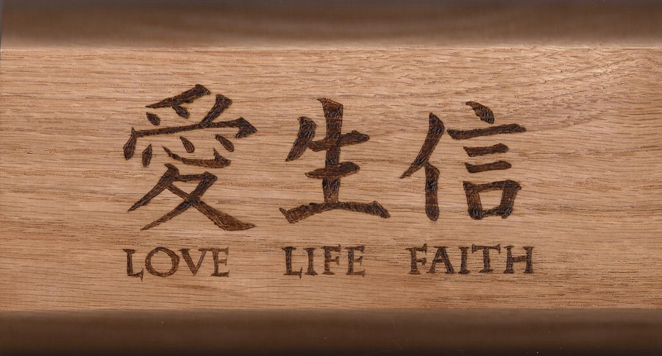

[9] There are those tender private moments, often at work when, for instance, Yoji realizes suddenly that every weekend when his wife cooks a meal, it contains his favourite potatoes. Or Tamiko will think about the sweater she is knitting for her husband “not because I have to but because I want to.” Or perhaps she will admire one more time the handcrafted ring that her husband bought from a jeweller secretly and gave it to her one evening. “I don’t know why I did it,” Yoji insists. “It was for no reason. I just wanted to see Tamiko smile back at my face. I like seeing her smiling.”

[10] Last year, on their wedding day, when she was a bride for only a few minutes, Tamiko said to herself, “I think that our love will start to grow from this moment on.” The other evening, after 13 months of marriage, she remembered that, whispering herself “it’s growing.”

- Circle the best answer.

- This article is about _____.

- romantic relationships among the young Japanese people
- An unusual example of a married Japanese couple
- the difficulties of a love marriage in modern Japan
- a successful example of an arranged marriage in Japan

- At the wedding ceremony of the couple, the bride’s father compared their new life together to a train ride on a long unknown track. “There may be curves and dark tunnels ahead,” he told them, “but we wish you a safe journey.” This comment suggests that _____.

- The father did not favour the marriage because they will have a lot of problems in the future
- The father opposed the marriage and felt that it had little chance of succeeding
- The father wanted them to be successful in their marriage although they would have difficult times
- The father was probably a retired train engineer, and he was talking about his job experience

- Paragraphs 2, 3 and 4 _____.

- give examples of their growing love for each other after they got married
- show how much Tamiko loves her husband although Yoji is not as happy as her
- make it clear that their relationship has not changed since their wedding
- mention the harmony between the young couple and Yoji’s parents

- The writer mentions the cost of the wedding and reception in paragraph 6 to _____.

- make a comparison between marriages in Japan and in Western countries
- show how important a wedding ceremony was in Japanese society
- give an example to show how difficult it was to get married in Japan
- attract the readers’ attention to the materialistic traditions of the Japanese people.

- A Westerner, upon reading paragraph 6, would be surprised that ______.

- October was the most popular month for wedding ceremonies in Japan
- the wedding and reception cost too much money
- the young couple had never kissed each other before their wedding day
- Yoji and Tamiko had a very short honeymoon

- What does ‘they’ refer to in paragraph 7?

- Food and housing costs
- Yoji and Tamiko
- Yoji’s parents
- Three children

- What is the main idea of paragraph 8?

- Tamiko complains about Yoji’s annoying habits all the time.
- Yoji’s untidiness makes Tamiko get angry with him.
- Although they do not have the same political views, they can still discuss them easily.
- Having different opinions and personalities does not make their marriage unsuccessful.

- On the whole, Yoji and Tamiko’s marriage seems to be _____.

- successful, and the love between the husband and wife is steadily growing
- a disappointment to both of them as they live through problems
- headed for failure because there are too many differences between them
- great because their parents still financially help them

- Circle the best answer.

- Overall, the young couple say their marriage is going well.

a) In some ways b) In other words c) In general d) Instead

- They almost always meet each evening to ride home together.

a) every now and then b) rather frequently c) quite rarely d) hardly ever

- Open signs of affection are not common.

a) communicating with each other c) behaving in a friendly manner
b) showing that they were in love d) having no interest in their relationship

- The newlyweds spent their wedding night in a nearby hotel.

a) young couple at the wedding ceremony c) married couple with a newborn baby
b) two lovers who wanted to have a wedding party d) man and the woman who have just married

- They started to dwell in the two upstairs rooms of the condo of Yoji’s parents.

a) live permanently b) make decorations c) pay a visit d) stay for a short time

- Politically, they have separate views.

a) similar b) ordinary c) radical d) different

- “I have to tell him to pick up his clothes and put them away or in the laundry box” says Tamiko.

a) Put the clothes away from Tamiko’s eyesight
b) Put the clothes to the place where they are regularly kept
c) Put the clothes in the laundry box
d) Put the clothes in a room which is outside of the house

- Choose the correct word form to fit into each sentence.

- marriage, to marry, married

- She’s married with two children, a boy and a girl.
- They want to marry in October.
- The older I get, the more I believe in marriage.

- arrangement, to arrange, arranged

- Mr. and Mrs. Morita had a(n) arranged marriage.
- I have to know what the arrangement is before I can agree to do the job.
- Try to arrange the meeting before noon if possible.

- growth, grow, growing, grown-up

- I was surprised that he had a grown-up daughter because he looked so young.
- The growth of the oil industry was the fastest in 1990s.
- In my village, farmers grow flowers in greenhouses and sell them to make a living.
- There is a growing demand for organic food, which never seems to stop.

- youngster, youth, young, youthful

- Young people are often idealistic but somehow selfish.
- That youngster wearing a red t-shirt is my nephew.
- It is not surprising to hear that old people do not understand the youth.

- to choose, choice, choosy, chosen

- It is your turn to choose.
- For the living room, the chosen colour is light blue.
- Children are sometimes very choosy about their food.
- Would you do it again if you had the choice.

- politician, politics, political, politically

- Who would like to be a politician in the future?
- Do you think it is politically wise to make that statement?
- You should consider the political consequences of your action.
- It is difficult to understand the politics of another country.

- expectation, expect, expected

- I had no expectation that he would ever write again.
- Do you really expect to be handed things on a silver platter?
- The baby arrived on the expected day.

- Discuss the following questions in groups.

- People in different cultures have different ideas about love. How is love defined in your culture? Do people in your culture get married because they love each other, or do they get married first and then begin to love each other afterwards?

- Do you think that romantic love provides a good foundation for marriage? Why / why not? Please give as many reasons as you can for your answer, and explain your reasons with examples from your own experience or the experiences of people you know.

- “Marriage kills love!” Do you agree? Why / Why not?

